Hotel Management System

Assume Antra has a client, which needs an application for Hotel Management. Application must be developed with technologies Angular, .Net Core Web API, Entity Framework Core, SQL Server Database. Clients needs the following operations in the application.

# Roomtypes: -

Should be able to Add/Update/Delete/List the Roomtypes. Room types could be Deluxe, Super Deluxe etc.

# Rooms: -

Should be able to Add/Update/Delete/List the Room. Status column should show if a room is available or not. If a room is already occupied, then it should not be booked again if it is occupied.

# Customers: -

Should be able to Add/Update/Delete/List the Customers. Assume that a customer can book only one room at a time.

# Services: -

Should be able to Add/Update/Delete/List the Services. Services will be linked to the room and are billable.

Below is the database design for the application. All primary keys should be automatically incremented value.

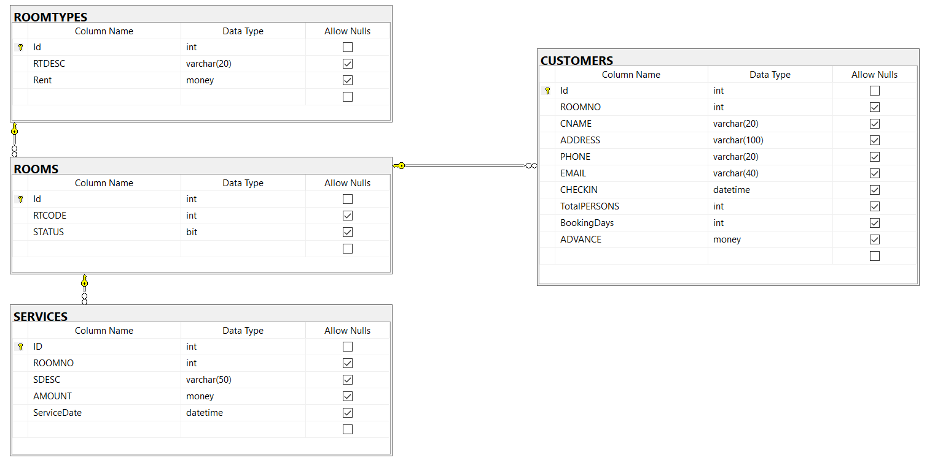

Guidelines:

1. Design the UI in Angular.
2. Database file must be created in SQL Server.
3. Connect with the database using Entity Framework Core.
4. Write the business logic in services using ASP.Net Web API Core.

# Deadline of the assignment

Finish your assignment in a day. Upload your code in Github with database script and share the link.

# Note

Create Specific repository interfaces and write code inside those repository classes

e.g. EmployeeRepository: IEmployeeRepository { }

then create services as illustrated during class

look into EF Core code-first approach with migrations...same as explained during class